Advanced SQL Server
Exercise-1:
Ranking and window functions
QUERY-
CREATE DATABASE CollegeLibraryDB;
GO
USE CollegeLibraryDB;
GO
CREATE TABLE Books (
BookID INT PRIMARY KEY,
BookName VARCHAR(100),
Genre VARCHAR(50),
Cost DECIMAL(10,2)
);

INSERT INTO Books (BookID, BookName, Genre, Cost) VALUES
(1, 'Python Basics', 'Programming', 800),
(2, 'Java Complete Guide', 'Programming', 1200),
(3, 'C++ Handbook', 'Programming', 700),
(4, 'AI Fundamentals', 'Programming', 1500),
(5, 'Physics Concepts', 'Science', 900),
(6, 'Chemistry Guide', 'Science', 1100),
(7, 'Biology Notes', 'Science', 600),
(8, 'Space Research', 'Science', 2000),
(9, 'English Grammar', 'Language', 500),
(10, 'French Learning', 'Language', 1000),
(11, 'Spanish Guide', 'Language', 750),
(12, 'German Basics', 'Language', 750);
SELECT * FROM Books;
ROW_NUMBER()
SELECT *
FROM (
SELECT
BookID,
BookName,
Genre,
Cost,
ROW_NUMBER() OVER(
PARTITION BY Genre
ORDER BY Cost DESC
) AS RowNum
FROM Books
) AS RankedBooks
WHERE RowNum <=3;
OUTPUT-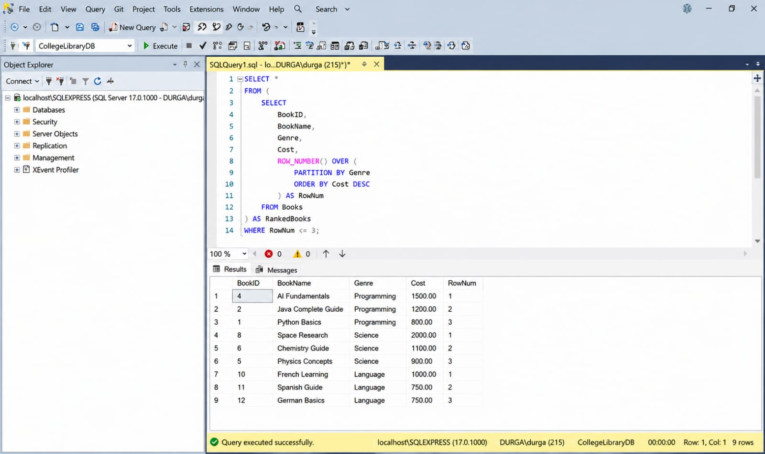

RANK()-
SELECT *
FROM (
SELECT
BookID,
BookName,
Genre,
Cost,
RANK() OVER(
PARTITION BY Genre
ORDER BY Cost DESC
) AS RankNo
FROM Books
) AS RankedBooks
WHERE RankNo <=3;
OUTPUT-
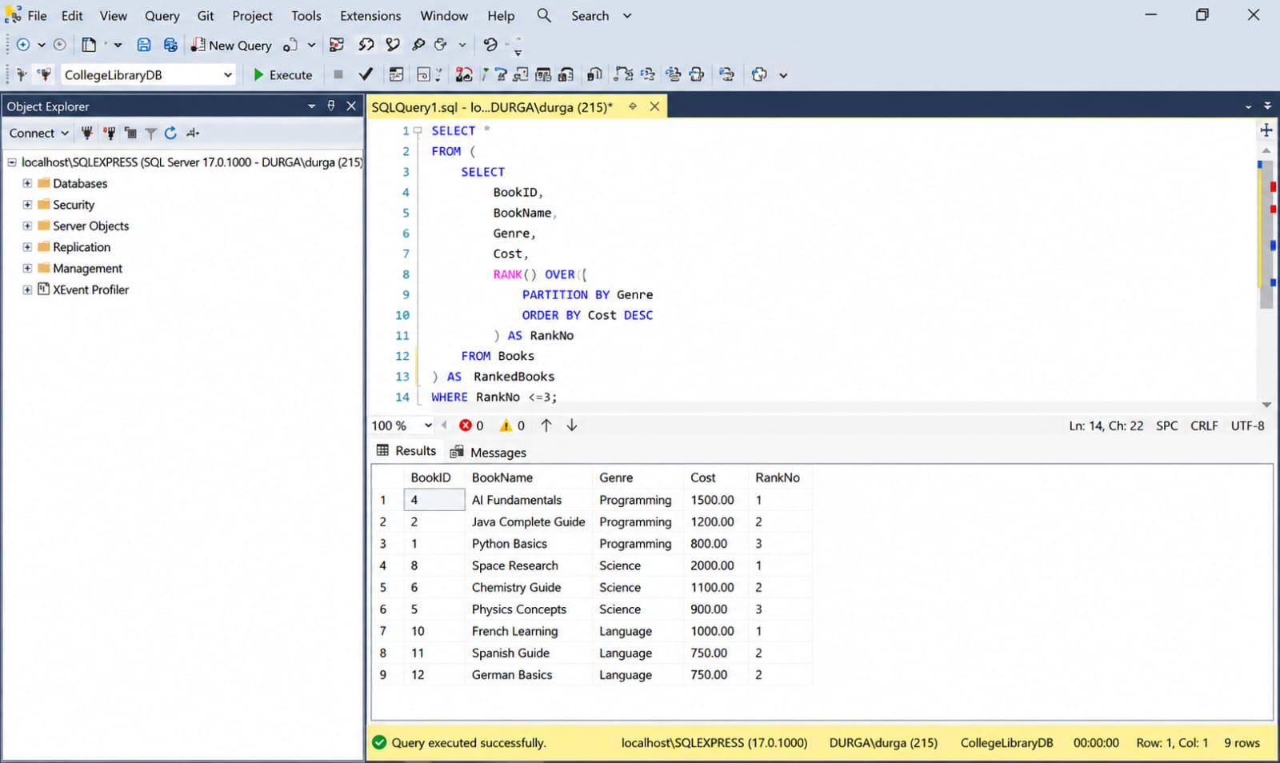
DENSE_RANK()-
SELECT *
FROM (
SELECT
BookID,
BookName,
Genre,
Cost,
DENSE_RANK() OVER(
PARTITION BY Genre
ORDER BY Cost DESC
) AS DenseRank
FROM Books
) AS RankedBooks
WHERE DenseRank <=3;
OUTPUT-
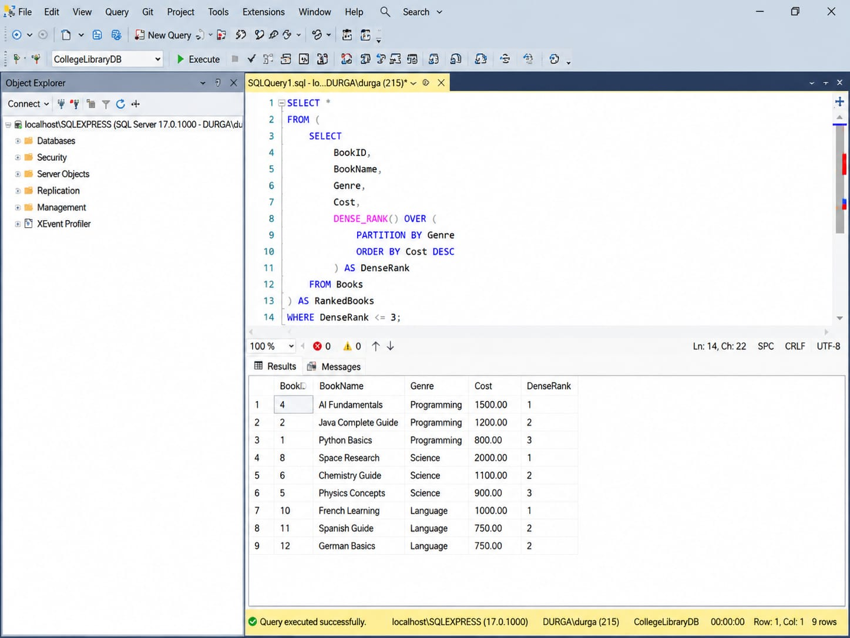
PARTITION BY-
SELECT
BookName,
Genre,
Cost,
ROW_NUMBER() OVER(
PARTITION BY Genre
ORDER BY Cost DESC
) AS RowNum
FROM Books;
ORDER BY-
SELECT
BookName,
Genre,
Cost,
ROW_NUMBER() OVER(
PARTITION BY Genre
ORDER BY Cost DESC
) AS RowNum
FROM Books;
OUTPUT-

